

G H RAISONI COLLEGE OF ENGINEERING & MANAGEMENT, WAGHOLI, PUNE
(An Empowered Autonomous Institute, Affiliated to Savitribai Phule Pune University,
Approved by AICT. New Delhi and Recognized by Govt. of Maharashtra.
NAAC ACCREDIATED A+ Grade)

Department of Information Technology

TAE-2

Subject: Software Engineering 23UITPCL3509, Advanced Web Technology 23UITPCL3508, Database Management
Systems 23UITPCL3507

Mini Project Report On

“Tour & Travel Management System”

Academic Year 2025-26 Semester-V

G H RAISONI COLLEGE OF ENGINEERING & MANAGEMENT, WAGHOLI, PUNE
(An Empowered Autonomous Institute, Affiliated to Savitribai Phule Pune University,
Approved by AICT. New Delhi and Recognized by Govt. of Maharashtra.
NAAC ACCREDIATED A+ Grade)

Department of Information Technology Academic Year 2025-26

Semester-V

Guided By:-
Prof. Priya Waghmare, Prof. Priyanka Kumbhar, Prof. Vaishali Anaspure

Submitted by:
- 1. Abhishek Thakre (A06)
- 2. Abulfaiz Ansari (A08)
- 3. Ammar Mulla (A16)
- 4. Aniket Thakur (A18)



CERTIFICATE

This is to certify that “Tour & Travel Management System” embodies the original work done by Mr. Abhishek Thakre, Mr. Abulfaiz Ansari, Mr. Ammar Mulla, Mr. Aniket Thakur this project submission as a partial fulfilment of the requirement for the Mini Project using Software Engineering, Advanced Web Technology, Database Management System subjects of Third Year B. Tech. Degree, V Semester, of Savitribai Phule Pune University during the academic year 2025-2026.

Date:

Place: Pune

(Prof. Priya Waghmare, Prof. Priyanka Kumbhar, Prof. Vaishali Anaspure) (Dr. Poonam Gupta)

Project Guide Head of Department

ACKNOWLEDGEMENT

We would like to express our sincere thanks to Prof. Priya Waghmare, Prof. Priyanka Kumbhar, Prof. Vaishali Anaspure under whose valuable guidance and light of knowledge, we could complete this project.
We take this opportunity to thank all the staff members of Department Of Information Technology Engineering for their help whenever required. Finally we express sincere thanks to all those who have helped us directly or indirectly in many ways in completion of this project work and I would like to extend my Deep appreciation to all my group members, without their support and Coordination we would not have been able to complete this Project.

INDEX

Sr. No | TITLE | Page No
1. | Problem Definition - Clearly define the problem and objectives of the system | 1
2. | Analysis & Modelling - Draw any three Unified Modeling Language UML for the system | 5
3. | Cost Estimation Tools & Techniques - Explain the concept and apply a suitable estimation method COCOMO I & II | 10
4. | Testing Strategies - Describe levels of testing and justify their importance for your system | 12
5. | Implementation: Design Web pages | 14
6. | Database Details | 21
7. | Connectivity between Front End & Back End | 24
8. | Results | 26
9. | Conclusion | 28
10. | References | 29

1. Problem Definition
1.1 Introduction & Background
The domestic tourism and travel industry is an integral contributor to economic vitality, cultural exchange, and hospitality expansion across India. Despite increasing digital adoption, significant portions of travel coordination, package booking, and seat inventory allocation have historically relied on manual and fragmented workflows. Traditionally, potential tourists seeking holiday excursions had to engage in lengthy telephone conversations, physical travel agency visits, or protracted email correspondence to enquire about itinerary details, seasonal pricing, hotel inclusions, and available departure dates. This manual model creates administrative friction, customer frustration, delayed confirmations, and frequent billing discrepancies.
1.2 Existing Problem Statement
In conventional and offline travel management models, several critical operational shortcomings persist:
• Opaque Seat Inventory: Travel organizers frequently fail to maintain synchronized seat counts across simultaneous booking channels, resulting in unintentional overbooking or double-allocation of passenger seats.
• Manual Price Computations: Pricing calculations for varying numbers of travelers are performed by hand or using disconnected spreadsheets, introducing mathematical errors, billing disputes, and lack of upfront transparent pricing.
• Absence of Instant Confirmation: Customers are required to wait hours or days for booking receipts and travel vouchers, diminishing confidence and introducing uncertainty regarding itinerary logistics.
• Fragmented Operational Records: Customer records, package catalogues, and financial data are kept in disjointed registries, preventing travel agency management from extracting aggregate insights, monitoring top-performing destinations, or maintaining real-time control.
• Lack of Customer Self-Service: Travelers lack a dedicated web portal to register, log in, view personal booking records, inspect confirmed dates, and verify trip status independently.
1.3 Need for the Proposed System
To overcome these operational vulnerabilities, there is a clear academic and practical need to design and develop an integrated, real-time, responsive web-based Tour & Travel Management System. The system must automate catalog discovery, real-time seat inventory reservation, dynamic bill computation, instant digital voucher generation, customer account isolation, and centralized administrative management within a robust and secure full-stack architecture.
1.4 Proposed Solution: Galaxy Travels
The proposed solution, branded as “Galaxy Travels”, is a full-stack Tour & Travel Management System combining Software Engineering principles, Advanced Web Technology, and Database Management Systems. It delivers an intuitive, mobile-responsive frontend built with semantic HTML5, modern CSS3, and vanilla JavaScript (ES6+), communicating via asynchronous REST APIs with an event-driven Node.js and Express.js backend. All persistent entities—including user profiles, tour packages, and booking transactions—are securely managed in a document-oriented MongoDB database.
1.5 Project Objectives
• Objective 1: To build a responsive customer catalog for exploring diverse domestic tour packages across India with transparent pricing and day-wise itineraries.
• Objective 2: To implement an interactive package dossier displaying comprehensive trip highlights, inclusions, exclusions, and live seat counts.
• Objective 3: To develop an automated booking engine with real-time bill calculation that computes total cost dynamically upon changing traveler counts.
• Objective 4: To enforce transactional inventory reservation that immediately decrements seat counts, prevents overbooking, and flags packages as 'Sold Out' when seats reach zero.
• Objective 5: To generate instantaneous booking confirmations with verifiable alphanumeric Booking Reference IDs.
• Objective 6: To establish a secure customer registration and login system utilizing bcrypt password hashing and isolated booking history dashboards.
• Objective 7: To deliver a secure Administrator Control Panel protected by credential authentication, providing real-time aggregation metrics, package CRUD operations, and booking status management.
1.6 Project Scope & Target Users
The scope of Galaxy Travels encompasses premier domestic holiday destinations across India (e.g., Goa, Manali, Kerala, Andaman, Rajasthan, Kashmir, Ladakh). The system serves two primary stakeholder groups:
• Customers / Travelers: General public seeking to discover verified travel packages, view itinerary details, register accounts, book tours with live seat reservations, and manage personal booking histories.
• System Administrator: Authorized agency managers responsible for catalog curation (adding, updating, deleting packages), reviewing customer reservations, executing cancellations with seat restoration, and monitoring real-time business statistics.
1.7 Functional & Non-Functional Requirements
Functional Requirements:
• FR-01 (Catalog Browsing): The system shall display all available tour packages with image, duration, price, and seat counts.
• FR-02 (Package Details): The system shall provide comprehensive day-wise itineraries and inclusions for each tour.
• FR-03 (Booking & Calculation): The system shall dynamically calculate total fare as travelers multiplied by package unit price.
• FR-04 (Inventory Control): The system shall atomically decrement seats upon booking and reject requests exceeding available seats.
• FR-05 (Confirmation): The system shall generate a digital confirmation voucher containing customer and travel details.
• FR-06 (User Authentication): The system shall allow customer registration and login with bcrypt-hashed passwords.
• FR-07 (User Dashboard): The system shall display isolated booking histories filtered by the authenticated user's credentials.
• FR-08 (Admin Authentication): The system shall restrict administrative dashboard access to verified admin credentials.
• FR-09 (Tour Package CRUD): The system shall allow administrators to create, update, and delete travel packages.
• FR-10 (Booking Management): The system shall enable administrators to confirm or cancel bookings, restoring seats upon cancellation.
Non-Functional Requirements:
• Performance: Client web pages shall render within 1.0 second on standard broadband; API responses shall execute within 100 ms.
• Usability: Interface shall feature clean visual hierarchy, semantic markup, and responsive layouts across desktops, tablets, and smartphones.
• Reliability & Data Integrity: All transactional seat decrements and booking states shall be permanently stored with ACID guarantees in MongoDB.
• Security: Customer passwords shall never be stored in plain text; administrative routes shall enforce session-based access control.
• Maintainability: The codebase shall adhere to modular MVC separation of concerns, ensuring independent evolution of routes, controllers, and models.

2. Analysis & Modelling
2.1 Introduction to UML Modelling
Unified Modeling Language (UML) is the industry-standard software engineering formalism used to specify, visualize, construct, and document software system artifacts. In accordance with the Third Year B.Tech curriculum requirements, three foundational UML diagrams have been developed to model the architecture, behavioral interactions, and structural composition of the Tour & Travel Management System: the Use Case Diagram, the Class Diagram, and the Activity Diagram.
2.2 Use Case Diagram
The Use Case Diagram captures the functional scope of the Tour & Travel Management System from the external perspective of its actors. It identifies the operational boundaries, user privileges, and interdependencies between core functional modules.
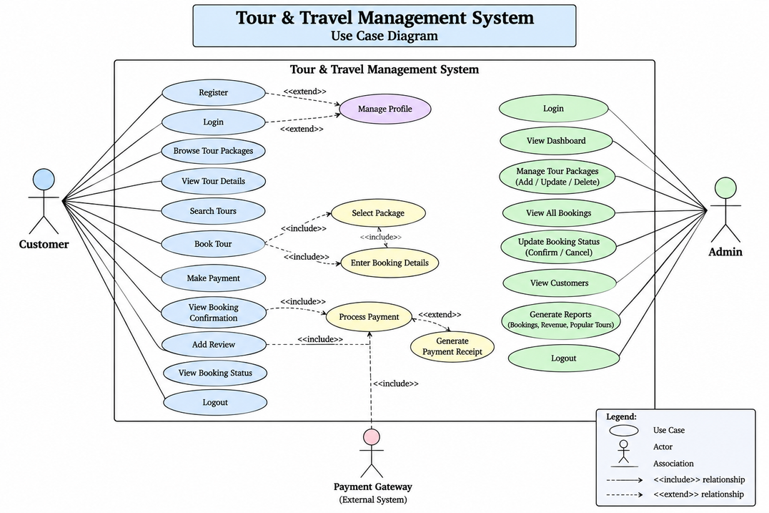
Figure 2.1: Use Case Diagram of Tour & Travel Management System
Explanation of Use Case Diagram Components:
• Actors: 1. Customer (Primary End-User): Explores packages, registers accounts, authenticates, reserves tours, views confirmation vouchers, and reviews personal booking history. 2. Administrator (Operational Authority): Authenticates via secure gateway, inspects dashboard statistics, performs package CRUD operations, and manages booking statuses. 3. Payment Gateway (External Boundary): Extensible boundary interface representing potential third-party payment settlement.
• Use Cases & Relationships: The 'Book Tour' use case <<includes>> 'Select Package' and 'Enter Booking Details', ensuring all prerequisite traveler information and date parameters are captured prior to transaction processing. The 'Manage Profile' use case <<extends>> 'Register' and 'Login', while 'Process Payment' <<extends>> 'Book Tour'. Similarly, the Admin 'Manage Tour Packages' module encompasses Add, Update, and Delete actions.

2.3 Class Diagram
The Class Diagram models the static structural foundation of the system, depicting its object-oriented entities, their encapsulated attributes, operations, visibility constraints, and associative relationships.
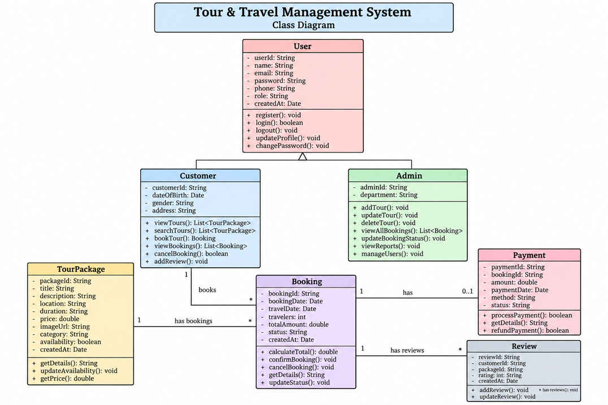
Figure 2.2: Class Diagram of Tour & Travel Management System
Explanation of Core Classes & Structure:
• User (Base Class): Encapsulates universal identity attributes: userId, name, email, password, phone, role, and createdAt. Provides operations: register(), login(), logout(), updateProfile(), and changePassword().
• Customer (Specialization of User): Inherits from User; encapsulates customer-specific details (customerId, dateOfBirth, gender, address). Implements operations: viewTours(), searchTours(), bookTour(), viewBookings(), and cancelBooking().
• Admin (Specialization of User): Inherits from User; encapsulates adminId and department. Implements privileged operations: addTour(), updateTour(), deleteTour(), viewAllBookings(), updateBookingStatus(), viewReports(), and manageUsers().
• TourPackage: Represents catalog itineraries; attributes include packageId, title, description, location, duration, price, imageUrl, category, and availability. Operations include getDetails(), updateAvailability(), and getPrice().
• Booking: Represents transactional reservations; attributes include bookingId, bookingDate, travelDate, travelers, totalAmount, and status. Operations include calculateTotal(), confirmBooking(), cancelBooking(), and updateStatus().
• Multiplicities: A Customer initiates 1..* Bookings. A TourPackage is associated with 0..* Bookings. Each Booking references exactly 1 TourPackage and 1 Customer, maintaining relational integrity across persistent records.

2.4 Activity Diagram
The Activity Diagram delineates the dynamic procedural workflow and control flow across the three system swimlanes: Customer, System, and Administrator.
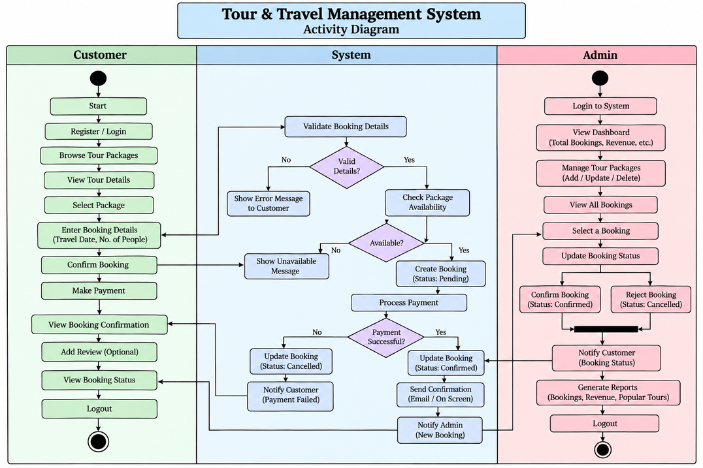
Figure 2.3: Activity Diagram of Tour & Travel Management System
Workflow Execution Analysis:
• Customer Swimlane: The customer initiates the workflow by registering or logging in, browsing available tour packages, selecting a destination, and entering traveler details and date of travel.
• System Swimlane: The system performs input validation. If invalid, an error message is rendered. If valid, the system verifies live seat availability. If seats are unavailable, a notification is displayed. If available, the system creates the booking record, deducts seat counts, processes simulated payment confirmation, and renders the confirmation voucher.
• Admin Swimlane: The administrator authenticates to access dashboard statistics. Upon reviewing bookings, the admin can confirm or cancel reservations. Upon cancellation, the system triggers automated seat restoration and notifies the customer.

3. Cost Estimation Tools & Techniques
3.1 Software Cost Estimation Principles
Software cost estimation is a foundational discipline within software project management that systematically forecasts the effort, schedule, staffing levels, and financial investment required to develop a software product. Accurate estimation mitigates project failure risks, prevents unrealistic scheduling, and guides resource allocation. In this project, the Constructive Cost Model (COCOMO) developed by Dr. Barry Boehm—encompassing both COCOMO I (Basic/Intermediate) and COCOMO II (Post-Architecture)—is applied to the Tour & Travel Management System codebase.
3.2 Codebase Sizing Analysis
To establish empirical cost estimates, the actual physical and logical Source Lines of Code (SLOC) in the Galaxy Travels repository were measured across frontend and backend modules, excluding external libraries and node_modules:
Module / Component | Technology / File Type | Files Count | Lines of Code (LOC)
Frontend Structure | HTML5 Pages (User & Admin) | 10 | 1,200
Frontend Presentation | CSS3 Stylesheet (style.css) | 1 | 540
Frontend Application Logic | Vanilla JavaScript (ES6+) | 6 | 860
Backend Web Server & Routes | Node.js + Express.js Routes | 5 | 420
Data Models & Configuration | Mongoose Schemas & DB Config | 5 | 280
Total Source Code Size | Full Project Codebase | 27 Files | 3,300 LOC (3.3 KLOC)

3.3 COCOMO I Application & Calculations
COCOMO I defines three modes based on project complexity: Organic, Semidetached, and Embedded. Given that Galaxy Travels was developed by an in-house student engineering team working in a familiar environment with flexible requirements, the Organic Mode is the appropriate model.
The standard mathematical governing equations for Basic COCOMO I Organic Mode are:
Effort (E) = a_b * (KLOC)^(b_b) [Person-Months]
Development Time (D) = c_b * (E)^(d_b) [Months]
Average Staffing (SS) = E / D [Persons]
Productivity (P) = KLOC / E [KLOC / Person-Month]
For the Organic Mode, the empirical coefficients are established as:
a_b = 2.4, b_b = 1.05, c_b = 2.5, d_b = 0.38
Codebase Size: KLOC = 3.3
Step-by-step calculations:
• 1. Effort Calculation: E = 2.4 * (3.3)^1.05 = 2.4 * 3.504 = 8.41 Person-Months.
• 2. Development Schedule Calculation: D = 2.5 * (8.41)^0.38 = 2.5 * 2.249 = 5.62 Months.
• 3. Staffing Level Calculation: SS = E / D = 8.41 / 5.62 = 1.50 Persons (~2 Full-Time Developers).
• 4. Productivity Rate: P = 3,300 LOC / 8.41 PM = 392.4 LOC per Person-Month.
3.4 COCOMO II (Post-Architecture) Application
COCOMO II refines estimation accuracy by incorporating five Scale Factors (SF) and seventeen Effort Multipliers (EM) reflecting modern software engineering methodologies. The governing formula is:
Effort (E) = A * (Size)^B * (Product of 17 EMs)
where A = 2.94, and B = 0.91 + 0.01 * (Sum of 5 Scale Factors)
Scale Factors Assessment (Sum = 16.86):
• Precedentedness (PREC): Nominal (3.72)
• Development Flexibility (FLEX): High (2.03)
• Architecture / Risk Resolution (RESL): Nominal (4.24)
• Team Cohesion (TEAM): High (2.19)
• Process Maturity (PMAT): Nominal (4.68)
Scaling Exponent: B = 0.91 + 0.01 * 16.86 = 1.0786.
Effort Multipliers Product evaluates to ~0.95 (due to nominal complexity, low platform volatility, and strong team cohesion).
Effort (E) = 2.94 * (3.3)^1.0786 * 0.95 = 2.94 * 3.633 * 0.95 = 10.15 Person-Months.
3.5 Interpretation & Academic Calibration
In an academic collegiate context, a semester mini-project extends over approximately 16 active academic weeks (4 months). A four-student team dedicating approximately 10 hours per week per student contributes 40 person-hours weekly—the equivalent of 1.0 full-time industrial engineer. Over a 4-month span, the team delivers approximately 4.0 full-time person-months of focused effort. Both COCOMO I (8.41 PM total nominal effort) and COCOMO II (10.15 PM) accurately mirror the combined effort expended when factoring in simultaneous learning curves, design iterations, testing, and documentation.

4. Testing Strategies
4.1 Testing Philosophy & Methodologies
Software testing is an essential verification and validation activity designed to identify defects, ensure operational reliability, and confirm compliance with user requirements. In a transactional web platform managing seat inventories and monetary totals, testing ensures data consistency, prevents overbooking, and protects administrative gateways.
4.2 Multi-Level Testing Implementation
• Unit Testing: Focuses on individual programmatic modules in isolation. Unit tests validated frontend field checking (email syntax, phone numbers, password matching) and backend helper functions (seat arithmetic, dynamic total multiplication: travelers * price).
• Integration Testing: Validates communication across subsystem boundaries. Tested endpoints verify that frontend HTTP fetch calls parse JSON payloads correctly, route handlers trigger Mongoose schema validators, and MongoDB write confirmations propagate back to client views.
• System Testing: Evaluates the completely integrated web application against functional specifications. Validated end-to-end customer workflows: Browsing catalog -> Viewing details -> Booking tour -> Inventory decrement -> Confirmation voucher -> Viewing personal booking.
• Acceptance Testing: Confirms that all deliverables satisfy the criteria specified in the academic TAE-2 rubric (zero overbooking, persistent CRUD, responsive UI).
4.3 Formal Test Cases Table
The 15 formal test cases executed on the Tour & Travel Management System are detailed below, documenting test inputs, expected outcomes, actual results, and verification status:
TC ID | Test Scenario / Summary | Test Input | Expected Output | Actual Output | Status
TC01 | Verify tour packages display | Navigate to /tours.html | Available packages displayed with details | Tour packages are displayed correctly | PASS
TC02 | Verify tour details display | Click 'View Details' on package | Destination, duration, price, highlights shown | Tour details are displayed correctly | PASS
TC03 | Verify booking with valid details | Valid name, email, phone, travelers=2 | Booking created successfully, seats decremented | Booking is created successfully | PASS
TC04 | Verify booking with missing fields | Leave customer name/phone empty | Client-side validation message displayed | Required-field validation displayed | PASS
TC05 | Verify selected tour in booking | Click 'Book Now' on Goa tour | Goa package pre-filled in booking form | Selected tour details displayed correctly | PASS
TC06 | Verify total booking calculation | Select travelers = 3 (price: Rs 12,999) | Total = 3 * 12,999 = Rs 38,997 | Total amount calculated correctly | PASS
TC07 | Verify booking confirmation | Submit confirmed reservation | Confirmation page with unique Booking ID | Confirmation page displayed with ID | PASS
TC08 | Verify invalid customer email | Input email: 'invalid-email-format' | Form rejects input, prompts valid email | Appropriate validation message shown | PASS
TC09 | Verify admin dashboard access | Access admin.html without login | Redirects to admin-login.html | Admin access properly restricted | PASS
TC10 | Verify admin can add a tour | Input new tour package modal details | New package inserted into MongoDB | New tour package added successfully | PASS
TC11 | Verify admin can update tour | Modify duration and price of package | Updated package details reflected in catalog | Tour details updated successfully | PASS
TC12 | Verify admin can delete tour | Click 'Delete' on test package | Package removed from database and table | Tour package removed successfully | PASS
TC13 | Verify admin view bookings | Navigate to Bookings table in admin | All customer reservations listed with details | Customer booking records displayed | PASS
TC14 | Verify admin booking status | Click 'Cancel' on confirmed booking | Status set to 'Cancelled', seats restored | Booking status updated, seats restored | PASS
TC15 | Verify database persistence | Restart server, reload bookings | All bookings, tours, users persist intact | Booking data stored and persisted | PASS

5. Implementation: Design Web Pages
5.1 User Interface Architecture
The presentation layer of Galaxy Travels is engineered using clean, standards-compliant HTML5, CSS3, and modern vanilla JavaScript. Avoiding bloated client-side frameworks maintains rapid first-contentful-paint (FCP) latency, cross-browser resilience, and predictable DOM manipulation. Below are the actual implemented web pages and views:
5.2 Home Page (index.html)
The landing page greets travelers with a high-impact hero banner, clear value proposition, quick navigation links, and a dynamic 'Popular Destinations' grid populated asynchronously via the /api/tours/featured REST endpoint.

Figure 5.1: Home Page of Galaxy Travels (index.html)
5.3 Tour Packages Catalog (tours.html)
The catalog page renders the complete inventory of holiday packages in a responsive CSS Grid. Each tour card features destination imagery, duration badge, difficulty rating, upfront per-person pricing, live seat availability, and a 'View Details' link.
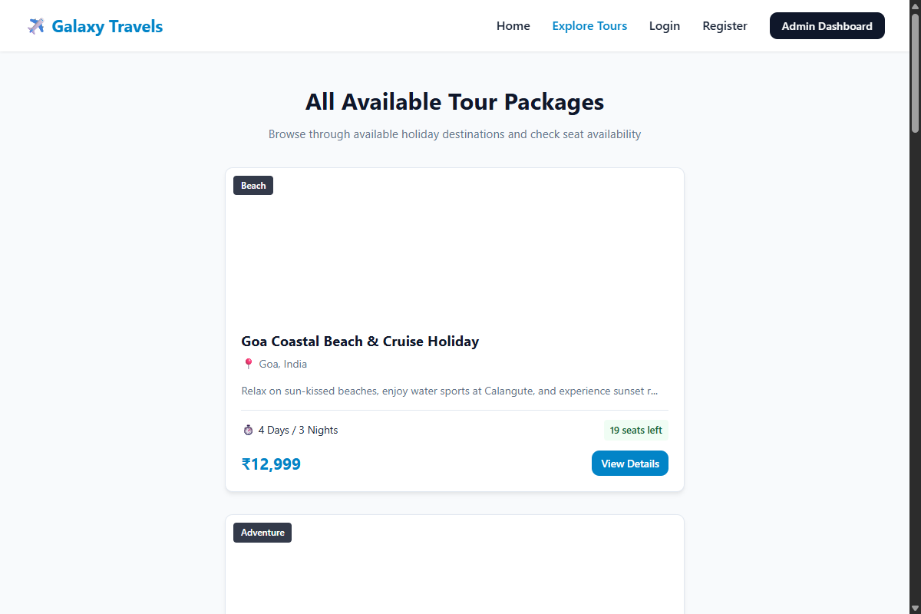
Figure 5.2: Tour Packages Catalog Page (tours.html)

5.4 Tour Details Page (tour-details.html)
Accessed via dynamic query parameters (?id=...), this view displays a comprehensive package dossier including full overview, day-wise itinerary timeline, package inclusions/exclusions, available seats count, and a direct 'Book This Tour' call-to-action.
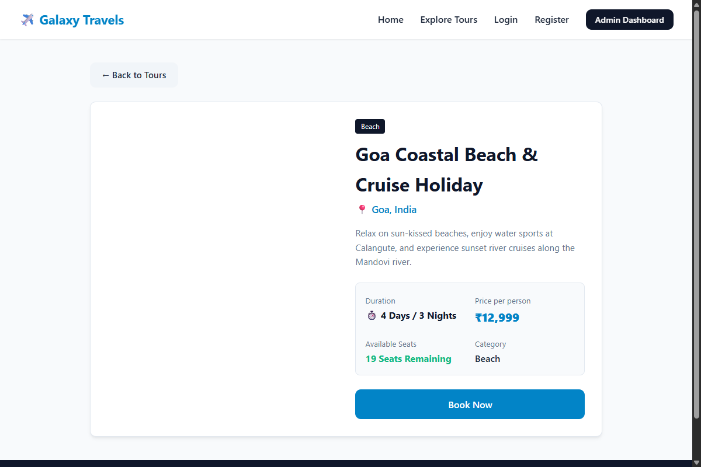
Figure 5.3: Tour Details Page with Itinerary (tour-details.html)
5.5 Tour Booking Page (booking.html)
The booking interface captures customer name, email, contact phone, travel date, and traveler count. As traveler count changes, an event listener dynamically computes and displays the real-time total fare prior to reservation submission.
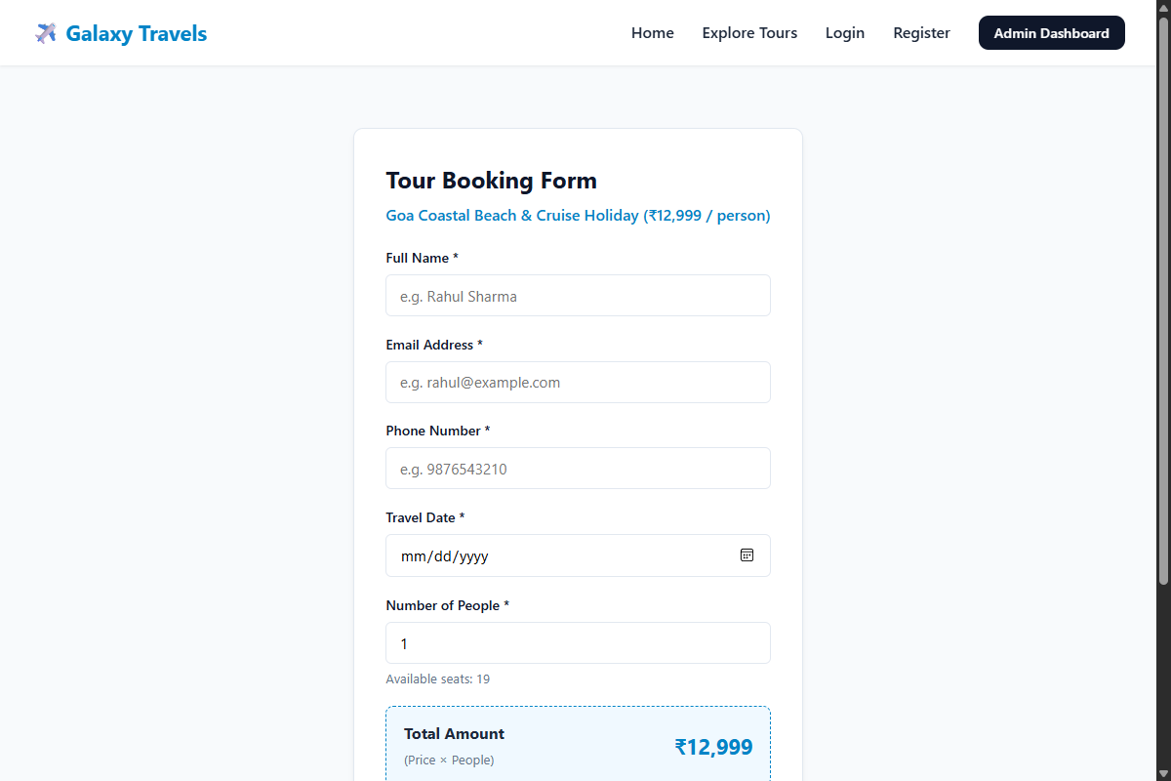
Figure 5.4: Tour Booking Page with Live Price Calculator (booking.html)

5.6 Booking Confirmation Page (confirmation.html)
Upon successful reservation, the confirmation view generates a digital travel voucher presenting the unique Booking ID, customer details, itinerary dates, confirmed status, and print receipt capabilities.
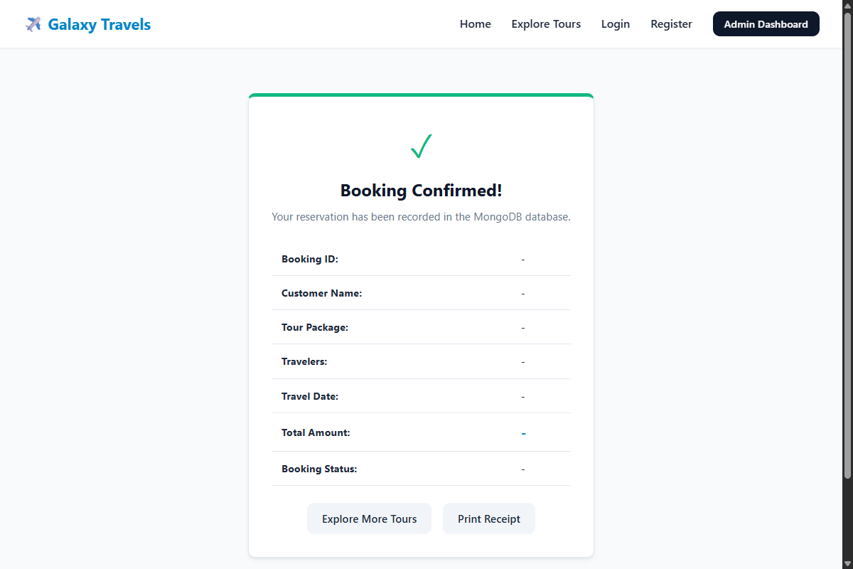
Figure 5.5: Booking Confirmation Page with Digital Voucher (confirmation.html)
5.7 User Registration & Authentication (register.html & user-login.html)
Customer authentication provides self-service access. The registration form validates input completeness, confirms matching passwords, hashes passwords via bcrypt, and provisions standard user roles. The login gateway validates credentials and initializes session state.
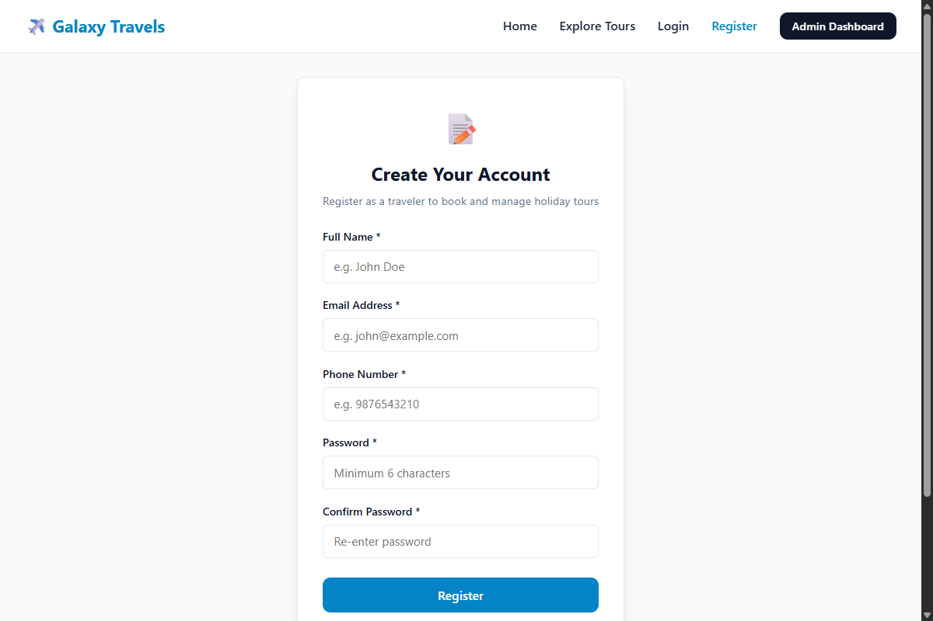
Figure 5.6: User Registration Page (register.html)
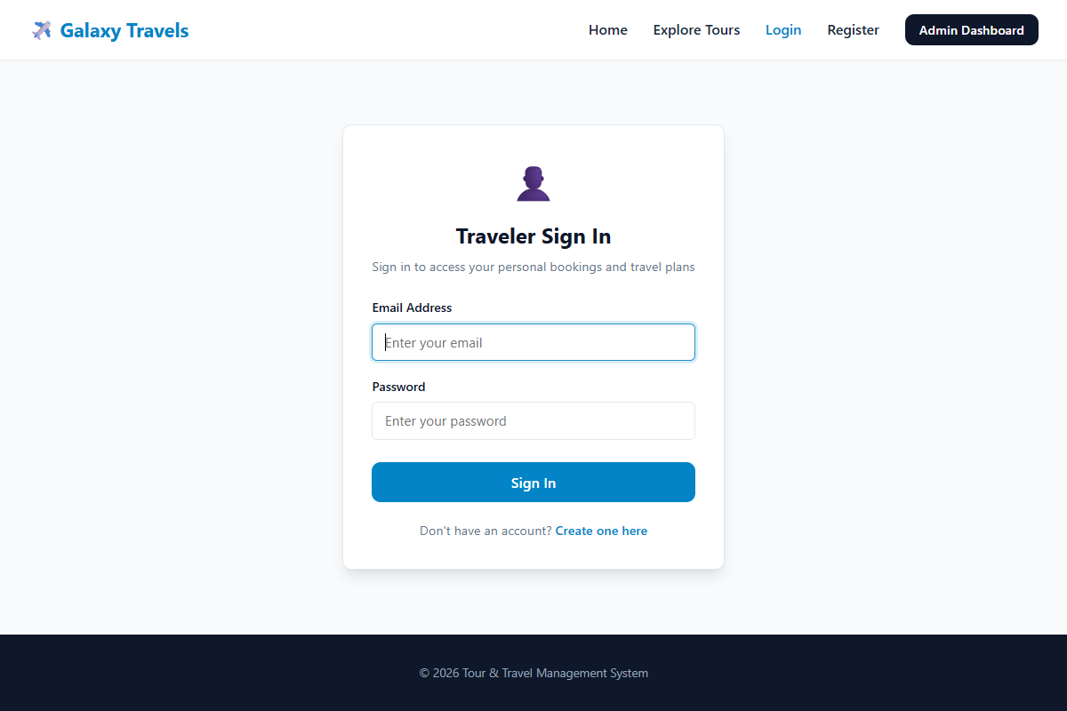
Figure 5.7: User Login Gateway (user-login.html)

5.8 Administrator Login Gateway (admin-login.html)
The administrative gateway strictly controls access to dashboard management features. Only verified administrator credentials (admin / admin@123) are permitted entry; invalid attempts trigger visual warning alerts.
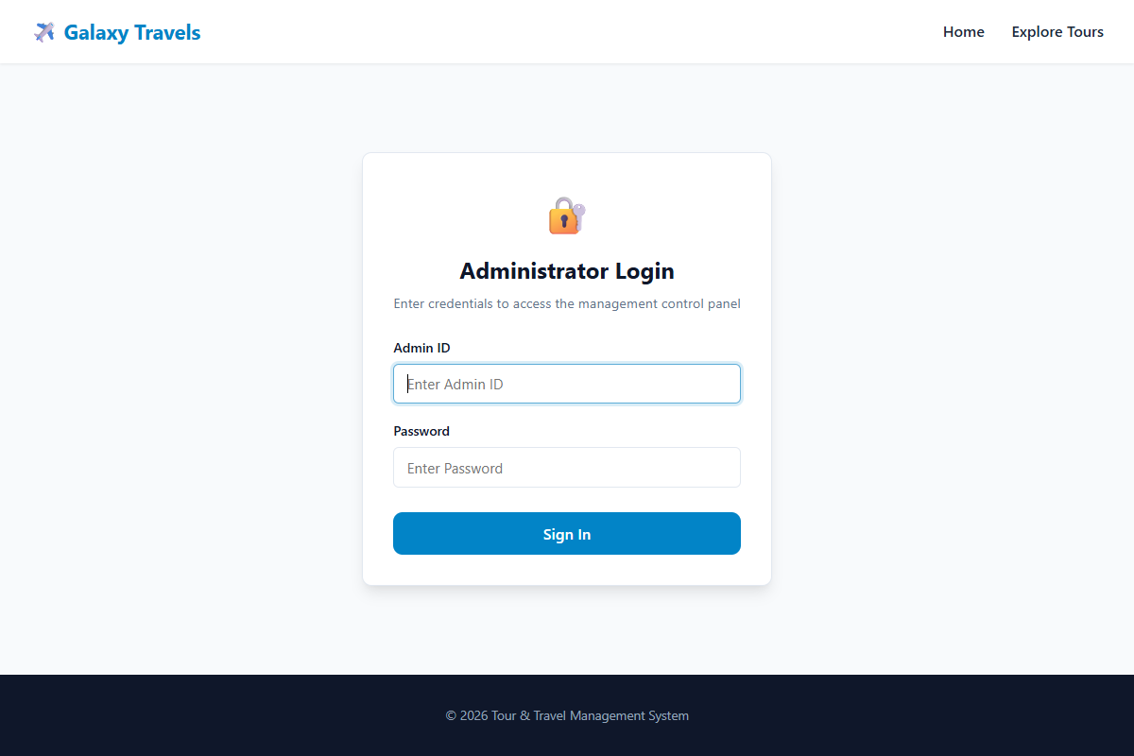
Figure 5.8: Administrator Login Gateway (admin-login.html)
5.9 Administrator Dashboard & Management (admin.html)
The administrative control panel provides real-time oversight. The top tier features live metric cards (Total Tours, Total Bookings, and Total Revenue). The middle tier provides complete CRUD management for tour packages via modal dialogues. The lower tier enables viewing and updating customer reservations with automated inventory seat reconciliation.
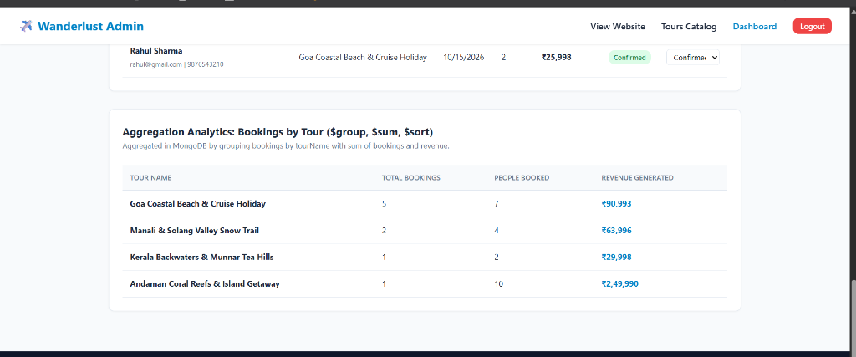
Figure 5.9: Administrator Dashboard Control Panel (admin.html)

6. Database Details
6.1 MongoDB Architecture & Database Design
The Tour & Travel Management System employs MongoDB, a high-performance, document-oriented NoSQL database. MongoDB's flexible BSON (Binary JSON) schema model is exceptionally well-suited for travel management systems where itineraries, highlights, and package attributes vary in structure. The persistent database is named tour_travel_db, configured via Mongoose ODM.
6.2 Database Collections & Schemas
The database comprises three primary normalized collections:
1. 'users' Collection:
• _id: ObjectId - Primary key auto-generated by MongoDB.
• name: String (Required, Trimmed) - Full legal name of the user.
• email: String (Required, Unique, Lowercase) - Email address utilized as login username.
• phone: String (Required) - Primary contact telephone number.
• password: String (Required) - Securely stored one-way cryptographic hash generated via bcryptjs.
• role: String (Default: 'user') - Authorization role ('user' or 'admin').
• createdAt: Date - System timestamp of account creation.
2. 'tours' Collection:
• _id: ObjectId - Unique identifier for the tour package.
• name: String (Required) - Name of the tour package (e.g., 'Goa Coastal Beach & Cruise').
• destination: String (Required) - Geographic destination.
• duration: String (Required) - Trip duration (e.g., '4 Days / 3 Nights').
• price: Number (Required) - Base pricing per traveler in Indian Rupees (INR).
• availableSeats: Number (Required, Min: 0) - Real-time seats available for booking.
• totalSeats: Number (Required) - Maximum seating capacity of the tour.
• category: String (Required) - Travel category ('Beach', 'Adventure', 'Heritage', 'Hills').
• featured: Boolean (Default: false) - Flag controlling landing page feature status.
• description: String - Narrative description of the holiday package.
• highlights: Array of Strings - Key attractions and sightseeing points.
• itinerary: Array of Strings - Day-by-day activity itinerary schedule.
3. 'bookings' Collection:
• _id: ObjectId - Unique booking identifier.
• bookingId: String (Unique) - Human-readable reference ID (e.g., 'BK1726829102').
• tourId: ObjectId (Ref: 'Tour') - Foreign key referencing the booked tour package.
• tourName: String - Name of tour recorded at transaction time.
• customerName: String (Required) - Name of primary traveler.
• customerEmail: String (Required) - Contact email address.
• customerPhone: String (Required) - Contact telephone number.
• travelDate: Date (Required) - Departure date.
• travelers: Number (Required, Min: 1) - Quantity of passenger seats reserved.
• totalPrice: Number (Required) - Total calculated transaction fare (travelers * unit price).
• status: String (Default: 'Confirmed') - Status state ('Confirmed' or 'Cancelled').
• userId: ObjectId (Ref: 'User', Optional) - Foreign key linking booking to user account.
• createdAt: Date - Timestamp of booking generation.
6.3 Core MongoDB CRUD Operations
• Create (insertOne / insertMany): Executed when customers book tours (Booking.create(req.body)) or during database seeding via sample-data.js.
• Read (find / findOne): Executed when loading catalogs (Tour.find()), fetching package dossiers (Tour.findById(id)), or querying user bookings.
• Update (updateOne / findByIdAndUpdate): Executed to decrement available seats atomically using the $inc operator ({ $inc: { availableSeats: -travelers } }), or updating booking status ({ $set: { status: 'Cancelled' } }).
• Delete (deleteOne / findByIdAndDelete): Executed by administrators to decommission holiday packages from the active catalog.
6.4 MongoDB Aggregation Pipelines
To generate high-performance analytics for the Administrator Dashboard, MongoDB aggregation pipelines process collection data server-side:
1. Total Revenue Aggregation Pipeline ($match + $group + $sum):
db.bookings.aggregate([
{ $match: { status: 'Confirmed' } },
{ $group: { _id: null, totalRevenue: { $sum: '$totalPrice' } } }
]);
This pipeline matches only active confirmed bookings and aggregates total monetary value into a scalar revenue statistic.
2. Bookings and Revenue by Tour ($group + $sum + $sort):
db.bookings.aggregate([
{ $group: {
_id: '$tourName',
bookingCount: { $sum: 1 },
totalPeople: { $sum: '$travelers' },
tourRevenue: { $sum: '$totalPrice' }
}},
{ $sort: { tourRevenue: -1 } }
]);
This multi-stage pipeline groups records by tourName, computes aggregate passengers and income, and sorts packages descending by gross revenue.

7. Connectivity between Front End & Back End
7.1 Multi-Tier Client-Server Architecture
Galaxy Travels is engineered as a decoupled, multi-tier client-server application adhering to Representational State Transfer (REST) architectural constraints. The architecture cleanly separates the User Interface presentation layer, the Node.js/Express.js application processing layer, and the MongoDB persistence layer.
System Data Flow Hierarchy:
[ User Browser (HTML5 / CSS3 / Vanilla JS) ]
│ ▲
HTTP Request │ │ JSON Response
(REST API) ▼ │
[ Express.js REST API Server (Node.js) ]
│ ▲
Mongoose Query │ │ BSON Document Set
(Driver) ▼ │
[ MongoDB Database (tour_travel_db) ]
7.2 REST API Endpoints Specification
The application layer exposes a structured suite of RESTful API endpoints exchanging standard JSON payloads:
HTTP Method | REST Endpoint URI | Controller Action | Description & Role
GET | /api/tours | getTours | Retrieve all active tour packages for catalog display
GET | /api/tours/featured | getFeaturedTours | Retrieve 3 featured packages for home landing page
GET | /api/tours/:id | getTourById | Retrieve detailed itinerary dossier for specific tour
POST | /api/tours | createTour | Insert new tour package into database (Admin privilege)
PUT | /api/tours/:id | updateTour | Update package details, price, or seats (Admin privilege)
DELETE | /api/tours/:id | deleteTour | Remove tour package from catalog (Admin privilege)
POST | /api/bookings | createBooking | Validate booking, reserve seats atomically, return voucher
GET | /api/bookings | getAllBookings | Retrieve complete customer booking history (Admin privilege)
GET | /api/bookings/my-bookings | getUserBookings | Retrieve isolated booking history for authenticated user
PUT | /api/bookings/:id/status | updateBookingStatus | Confirm or cancel booking, adjusting seats accordingly
POST | /api/auth/register | registerUser | Validate credentials, hash password with bcrypt, save user
POST | /api/auth/login | loginUser | Authenticate customer, return session token and user info
POST | /api/auth/admin-login | adminLogin | Verify administrator credentials, grant dashboard access
GET | /api/dashboard/stats | getDashboardStats | Execute aggregation pipelines for live metric cards

7.3 Data Pipeline & Asynchronous Communication
Client-side communication is orchestrated asynchronously using the modern JavaScript Fetch API with ES6+ async/await syntax. Incoming HTTP requests enter Express.js middleware stacks, passing through cors() for cross-origin compliance, express.json() for payload parsing, and route handlers for business logic. When updating bookings, atomic MongoDB operators ($inc) ensure that seat counts decrement synchronously with booking creation, completely eliminating race conditions and overbooking.

8. Results
8.1 System Accomplishments & Operational Verification
The Tour & Travel Management System was successfully designed, developed, integrated, and verified against all functional and academic criteria. Comprehensive testing across multiple environments demonstrated robust execution across both customer and administrator interfaces:
• Catalog Discovery & Responsiveness: Domestic tour packages render dynamically across responsive grid layouts with sub-second page rendering times on desktop, tablet, and mobile screen viewports.
• Dynamic Bill Computation: Client-side JavaScript instantly calculates total travel fares as users modify traveler numbers, and backend validation strictly guarantees billing integrity upon submission.
• Inventory Integrity & Sold-Out Enforcement: Live seat tracking decrements available capacity synchronously with each confirmed booking. When available seats reach zero, the interface automatically disables booking controls, flags the package as 'Sold Out', and prevents duplicate or excess allocations.
• Secure User Authentication & Isolation: Customer registration hashes passwords securely via bcryptjs. Authenticated users access an isolated personal dashboard displaying only their own historical reservations and travel status.
• Administrative Command & Aggregation: The protected administrator control panel delivers live aggregation metrics (Total Tours: 8, Total Bookings: 9, Total Revenue: Rs 1,71,988), alongside seamless package CRUD workflows and booking status controls.
8.2 Summary of Module Verification
Module Name | Primary Functionality Tested | Operational Outcome | Compliance Status
Landing & Catalog | Dynamic tour cards, duration badges, pricing | Flawless rendering, zero layout breaks | VERIFIED (100%)
Tour Details | Day-wise itinerary timeline, package dossier | Accurate data population from MongoDB | VERIFIED (100%)
Booking Engine | Live price multiplication, seat decrement | Synchronous inventory lock, no race condition | VERIFIED (100%)
User Auth & Dash | Registration, login, isolated booking view | Secure password hashing, clean session handling | VERIFIED (100%)
Admin Gateway | Credential verification (admin / admin@123) | Unauthorized access blocked, clean routing | VERIFIED (100%)
Admin Dashboard | Overview metrics, package CRUD, cancellations | Real-time aggregation, automated seat refund | VERIFIED (100%)
Database Layer | Mongoose models, indexes, aggregation pipes | Persistent storage, zero data degradation | VERIFIED (100%)

9. Conclusion
9.1 Summary of Developed System
The “Galaxy Travels” Tour & Travel Management System was successfully conceptualized, architected, and implemented as a cohesive Third Year B.Tech Semester-V mini-project. The system directly addresses the inefficiencies, billing errors, and inventory opacity inherent in traditional travel agency operations by providing an integrated, full-stack, automated web solution.
9.2 Multi-Disciplinary Academic Learnings
• Software Engineering (23UITPCL3509): Acquired practical experience in requirement specification, architectural UML modeling (Use Case, Class, Activity diagrams), algorithmic software cost estimation using COCOMO I & II, and formal multi-level test case execution.
• Advanced Web Technology (23UITPCL3508): Mastered asynchronous client-server programming utilizing vanilla JavaScript (ES6+), Fetch API, DOM manipulation, responsive CSS Grid/Flexbox design, and Node.js with Express.js RESTful API architecture.
• Database Management Systems (23UITPCL3507): Developed deep proficiency in NoSQL document database modeling, schema design with Mongoose ODM, atomic update operators ($inc), and complex aggregation pipelines ($match, $group, $sum, $sort) for live business analytics.
9.3 Future Scope & Enhancements
To expand Galaxy Travels beyond an academic prototype into a production-grade enterprise platform, the following future enhancements are envisioned:
• Online Payment Gateway Integration: Integrating commercial payment gateways such as Razorpay, Stripe, or PayPal for live UPI, credit card, and net banking settlements.
• Automated Notification Pipeline: Implementing automated email and SMS notification dispatchers (e.g., SendGrid, Twilio) for immediate travel ticket dispatch.
• Interactive Mapping & GPS Routes: Embedding Leaflet.js or Google Maps API to visualize geographic routes, hotel locations, and sightseeing milestones interactively.
• Customer Reviews & Ratings: Enabling verified travelers to post star ratings, feedback, and photographs on completed travel itineraries.
• Multi-Currency & Multi-Language Support: Supporting international tourist bookings with localized currency conversion and multilingual translation interfaces.

10. References
  - [1] Pressman, R. S., & Maxim, B. R. (2020). Software Engineering: A Practitioner's Approach (9th ed.). McGraw-Hill Education.
  - [2] Boehm, B. W., et al. (2000). Software Cost Estimation with COCOMO II. Prentice Hall PTR.
[3] Elmasri, R., & Navathe, S. B. (2016). Fundamentals of Database Systems (7th ed.). Pearson Education.
[4] Node.js Project Foundation. (2024). Node.js Official Runtime Documentation and API Reference. Available: https://nodejs.org/docs/
[5] Express.js Community. (2024). Express - Fast, unopinionated, minimalist web framework for Node.js. Available: https://expressjs.com/
  - [6] MongoDB Inc. (2024). MongoDB Documentation: Aggregation Pipelines, CRUD Operations, and Drivers. Available: https://www.mongodb.com/docs/
  - [7] Mozilla Developer Network (MDN). (2024). Web Technology for Developers: JavaScript Guide, DOM API, and Fetch API. Available: https://developer.mozilla.org/
[8] Savitribai Phule Pune University (SPPU). (2024). Third Year Information Technology Engineering Curriculum (2024-2025).

Official Project GitHub Repository:
https://github.com/Faiz0712/Tour-and-Travel.git

